# Bitcore Address & QR Code Generator

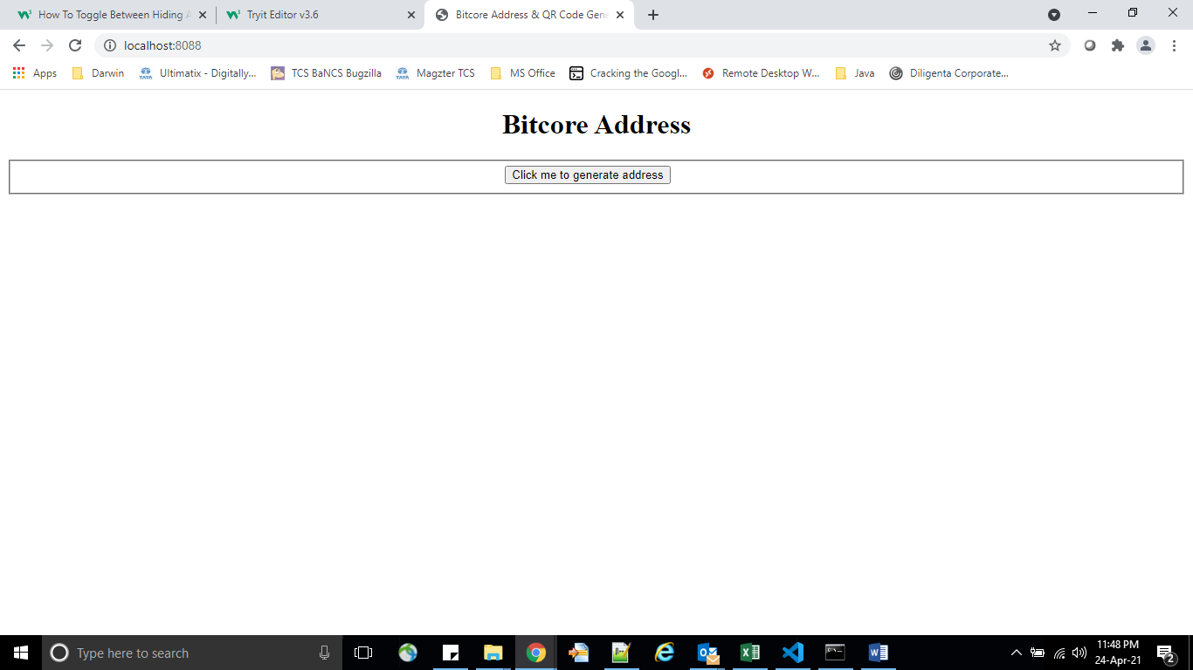

This is the very first page. Initially, there’s no address in it. The user must click on that “*Click me to generate address*” button to generate address.

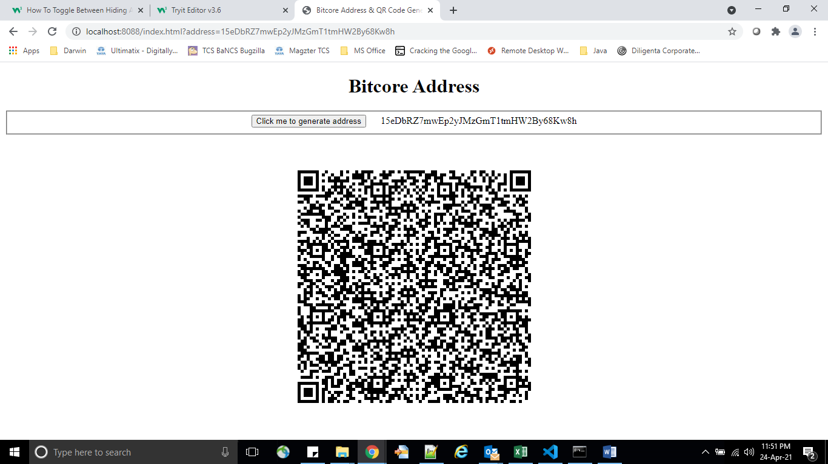

Once, the button is clicked, the address is shown alongside this button while the QR code containing the address is shown below.